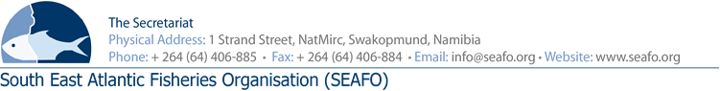

PROVISIONAL AGENDA FOR THE 15TH MEETING OF THE SCIENTIFIC
COMMITTEE (SC) - 2019

CHAIRPERSON: Mr. Ǻge Høines (Norway 2019 - 2021) VENUE: Strand Hotel, Swakopmund
VICE-CHAIR: Mr. Granville Louw (SA 2019 - 2021) DATE: 19-22 November 2019

Item | Agenda Item | Working Document
1 | Opening of meeting by Chairperson
2 | Appointment of Rapporteur
3 | Adoption of agenda and meeting arrangements | DOC/SC/01/2019  DOC/SC/02/2019
4 | Introduction & admission of Observers
5 | Introduction of Delegations
6 | Review of submitted SEAFO working documents and any related presentations, allocations to the agenda items | DOC/SC/00/2019
7 | Review of the 2019 work program | DOC/SC/02/2019  DOC/SC/03/2019  DOC/SC/04/2019  DOC/SC/05/2019
8 | Report by the Executive Secretary presenting landing tables updated to September 2019 | DOC/SC/06/2019
9 | Review spatial and temporal distribution of fishing activity and biological data | DOC/SC/06/2019
10 | Review the spatial distribution of reported catches of benthic organisms | DOC/SC/06/2019
11 | Review Stock Status Report  11.1 Patagonian toothfish  11.2 Orange roughy  11.3 Deep-sea crab  11.4 Pelagic armourhead / Southern boarfish  11.5 Alfonsino | DOC/SC/07/2019  DOC/SC/08/2019  DOC/SC/09/2019  DOC/SC/10/2019  DOC/SC/11/2019
12 | Review research activities in the SEAFO CA since October 2018
13 | Examine, where appropriate, assessments and research done by neighboring States and other organisations | DOC/SC/12/2019
14 | Proposal for amendment of the rules of procedure of the SEAFO Scientific Committee | DOC/SC/13/2019
15 | Data Request & Research Proposals | DOC/SC/14/2019  DOC/SC/15/2019  DOC/SC/16/2019  DOC/SC/17/2019  DOC/SC/18/2019
16 | Any other matters
17 | Collate advice and recommendations to the Commission on issues emanating from the 2019 meeting
18 | 2020 Work Program
19 | Budget for 2020
20 | Adoption of the report
21 | Date and place of the next meeting
22 | Closure of meeting

Circulation Date: 19 October 2019

